# freETarget

Application Note: Using the Accessory Port

**SUMMARY**

This application note describes the accessory port and it’s operation. Detailed applications of the accessory port can be found in other application notes.

**INTRODUCTION**

The freETarget signal processor board supports an accessory connector for driving peripherals such as a witness paper roller, or a long distance serial port. With this, the user can add a WiFi connection or RS-422 line driver to connect freETarget over a longer distance. The implementation of a long distance driver is the topic of another application note.

**ELECTRICAL**

The accessory connector is illustrated in Figure 1.

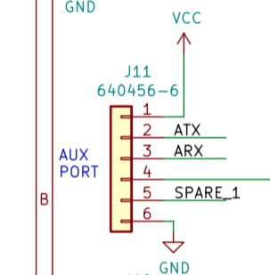

Figure 1: Accessory Connector

The pin description is provided in Table 1.

Table 1: Accessory Connector Signals

|  |  |  |
| --- | --- | --- |
| PIN | Description | Notes |
| 1 | 5VDC | Five-volt supply to drive interfaces. Limit 50mA at 5VDC |
| 2 | Auxiliary Transmit Data | TTL level transmit line 115200, N, 8, 1 |
| 3 | Auxiliary Receive Data | TTL level receive line 115200, N, 8, 1 |
| 4 | Motor Drive | Current sink through MOS-FET transistor. Limit 1A at 24VDC |
| 5 | Spare | Unused GPIO 22 for future expansion |
| 6 | Ground | Logic ground |

**OPERATION**

The intended operation of each of the pins is described in this section.

**5 VDC Power Supply**

The accessory connector provides a low current source to drive an interface card such as TTL to RS-232 convertors.

**Auxiliary Transmit**

The auxiliary transmit provides

* Duplicate shot information JSON message, ex {“SHOT”:1 …. }
* Responses to JSON commands from the host, ex {“VERSION”: … }

The auxiliary transmit does not support firmware downloads over the serial port; this is only handled by the main USB port.

**Auxiliary Receive**

The auxiliary receive listens to and responds to JSON commands. This provides a back door means to control freETarget from a second PC. Mostly used to synchronize a firing point and display PC when needed

**Motor Drive**

A control to drive a witness paper roller is provided by the Motor Drive Pin. This pin provides a ground connection through a MOS-FET transistor.

The user has the option of turning on a DC motor for a period of time, or issuing pulses to a stepper motor controller. The number of pulses and the pulse duration is available from the setup page on the PC program. The duration of the motor control will be installation dependent and found by trial-and-error

IMPORTANT – No Flyback Diode

The user must provide a flyback diode on the motor if needed. The circuit does not incorporate any reverse current protection.

IMPORTANT – Stepper Motor Control

The software provides the ability to pulse a stepper motor circuit for a given number of pulses and periods. The user must add a stepper motor interface such as A4988 available from Amazon to convert from pulses to motor phase drive

**SPARE**

An unassigned GPIO (D22) is brought to the connector for individual applications when needed

**LOGIC GROUND**

Logic ground is provided on Pin 6